
NOVEMBER 2021
South Leicestershire Group URC



SOUTH LEICESTERSHIRE GROUP UNITED REFORMED CHURCH
Saffron Lane-Wigston Magna-South Wigston
Oadby-Whetstone
http://southleicsgroupurc.org.uk

Part of the South and East Leicestershire Area with Abbots Rd URC
Contact us:
Reverend Richard Eastman 0116 2714751
South Leicestershire Group Minister
Mrs Eileen Williams 0116 2478929
Local Church Leader
Revd Martin Ferris 0116 2419357
Resource Minister South and East Leicestershire Area

South Wigston
Di Statham Secretary 0116 2810053
Noel Oldershaw Treasurer 0116 2813398
Marion Bartholomew Magazine 0116 2717755

Wigston Magna
Eileen Williams Secretary 0116 2478929
Ray Green Acting Treasurer 0116 2887774
Ray Green Room Lettings 0116 2887774 /
07518 214144
Mary Childs Brigades Contact 07946093786
Sheila Stephens Magazine 0116 4315206
Church Office answerphone 0116 2882666

Saffron Lane
Sandra Clay Secretary/Finance/Magazine 0116 2835375
Elizabeth Richardson Treasurer 0116 2993176

Oadby
Pauline Hudson Secretary 0116 2712913
Tony Hudson Treasurer 0116 2712913

Whetstone
Janet Statham Correspondence Secretary 0116 2863335
Glenis Chapman Treasurer
Jean Warner Room Lettings 0116 2752405
Kevin West Magazine 0116 2779402

Abbots Road
Revd Pam Smith Secretary 07830037308
Eric Hanson Treasurer
THANK YOU AND AU BIENTOT, (SEE YOU LATER, NOT GOODBYE)
On behalf of myself and the Eastman family, I would like to say thank you for having us! It has been a privilege to serve the South Leicestershire Group as a Stipendiary Minister. I know that some would say that I have been here too long, but there was never a right time to move because of various circumstances, mainly to do with schooling opportunities and it being the right time to contemplate a change. There was always the sense of unfinished work to be completed. I have at various times explored opportunities, but there was never the feeling that I was being urged to move on. I have of course moved within the Group; my original call churches were South Wigston and Saffron Lane. All six churches in the Group have their own unique context; all of the churches have their unique challenges, some were met, some not. I have been successful in some areas, but not as much as I would have liked to have been. For all the things that I have not managed to achieve, I regret not being more assertive. My attitude is ‘these folks are adults and know how much they want to put into their discipleship’. One limited success was the monthly Group Bible Study, we have had some interesting discussions, and I have learnt some things that I would not have picked up had I not been looking at scripture through other people’s eyes and thought processes. The hard work starts now as we enter into a new phase of ministry for the South Leicestershire Group and the newly declared ‘South and East Leicestershire Area, (SELA). It will need a greater effort by many people to make the new model of ministry effective. I know that all the Elders across the Group will do their best to support Martin as he guides the Six churches in the South and East Leicestershire Area (SELA).

We will not be going far away, there are very good reasons for staying in the area and these have been discussed with the Moderator. I will be taking a break away for quite a few months. The expectation from Synod is that I will ‘keep my nose out of SELA business’. I will be available for preaching duties at the end of my break, but probably limited to once per month. Shirley is still available to lead worship.

As we move on, I am aware of the great privilege I have been given; to be alongside people when they were filled with joy and also to be alongside them in more trying circumstances. I have had the privilege of meeting many people who have had some remarkable life stories and experiences. I have also had the experience of serving the wider church on various committees and working groups. The main thing that I have learnt is ‘there’s nowt as queer as folk’. We all have different ways of doing things, which means that there is a multitude of ways that many of you can take the Group churches forward. My sincerest wish and fervent hope is that the churches will adapt to new ideas and grow, but it will take a new mindset to achieve progress. You may have to think outside of the box, just as Jesus did when he ministered to tax collectors (sorry HMRC), prostitutes, the lame, the sick, the blind, and anyone else that the authorities thought were unworthy of God’s love. There will be a great need for the church universal to respond to the needs of the poor and the oppressed. It might even be sensible for two of our smaller congregations to merge into one. As we enter into new challenges for our community (higher energy bills/ecological issues/food issues) it might mean that we have to greater cooperation between the denominations in the guise of Churches Together to address food poverty issues, and possibly working with brothers and sisters of other faiths (and none) to help in our effort to support the community in the difficult times ahead.

I hope that you will all go from strength to strength as you develop your discipleship and continue to know that God loves you. (see John 3:16).

With all best wishes,

Richard, Shirley and Stephen.

SUNDAY SERVICE TIMES

Whetstone URC 10.00 am

Oadby URC 10.15 am

South Wigston URC 10.30 am

Wigston Magna 10.30 am

Saffron Lane 11.00 am

Abbots Road 10.45 am

Please check with the relevant Church Secretaries to confirm when services are taking place at any of the Group Churches.



Regular Group Church Events

MEETINGS / EVENTS ARE STARTING TO RECOMMENCE
For more information please contact the Church Secretary

South Wigston
Di Statham Secretary 0116 2810053

Wigston Magna
Eileen Williams Secretary 0116 2478929

Saffron Lane
Sandra Clay Secretary 0116 2835375

Oadby
Pauline Hudson Secretary 0116 2712913

Whetstone
Janet Statham Correspondence Secretary 0116 2863335
Jean Warner Room Lettings 0116 2752405

Abbots Road
Revd Pam Smith Secretary 07830037308

DEADLINE FOR DECEMBER 2021 / JANUARY 2022 MAGAZINE

Sunday 21 November 2021

Send your items to your church representative or direct to
di.statham@btinternet.com

If you do not have a computer a hand written copy can be accepted. Contact Di Statham 0116 2810053 for information

GROUP ANNIVERSARY SERVICE

SUNDAY 28 NOVEMBER 2021

OADBY URC

4.00 PM

Followed by

Shared Tea
(For Covid Safety please bring your own food)

And

An Opportunity to wish
Revd Richard Eastman

“Happy Retirement”


We are still here after 50 years. What does that say to us? And what is God saying to us? What opportunities does it give us to reflect on our story, on who we are, on what we stand for, on who we follow - and to share that with others?
As local churches and as the URC, marking our 50th year can help us to plan for the future – not only to keep pursuing our ecumenical vision, but also to plan for how we will continue to be an active, engaged and faithful Christian presence in our communities and in new ones. Not least, marking our Jubilee will be an opportunity to give thanks.

URC at 50: Worship Resources Competition
To celebrate the URC's 50th anniversary, choirs, bands, individuals, songwriters, composers, and poets are invited to submit an entry into the URC at 50: Worship Resources Competition.
There are four categories in which you can enter:
- traditional hymn/song
- poem
- contemporary hymn/song
- rap
Judges will select a winner from each category. Winning entries will be included in a digital version of the URC at 50 resource pack for local churches for them to use in jubilee celebrations and/or Sunday services.

Judging schedule
The closing date for entries is 8 April 2022.
Judges will assess each entry in May 2022.
Winners will be informed in June 2022.
Winners will be publicly announced at General Assembly in July 2022, at which the songs, or recordings, will be performed/played/sung.
The winning entries will be recorded and/or filmed in July 2022 for sharing online.
Cont………….

Criteria
To enter, you must be a member or active adherent of a URC or a URC local ecumenical partnership, or URC Youth.
Entries can be new lyrics submitted to existing music within the public domain.
Entries must have a jubilee/URC at 50 anniversary theme and be suitable for use in collective worship.
Musical entries to new tunes must include lyrics plus musical score (PDF or JPG) and/or an audio recording (MP3 or MP4).
The competition is open to people of any age.
One entry per person/group.
Submit entries to: mission@urc.org.uk

Prizes
Winning entries will be played/performed at General Assembly in the Jubilee year. Winners will be awarded a commemorative trophy.
Winning entries will be included in a URC at 50 resource pack for local churches for them to use in local jubilee celebrations and/or Sunday services.

Please note: The URC reserves editing rights to ensure entries comply with copyright and are suitable for distribution across the denomination. Entrants will be contacted to ensure they agree with any changes made. In addition, the copyright of the work submitted needs to be with the individual/group or shared/managed by the URC, it must not be work published by any other body.
Download the documents below to find out more about the Worship Resources Competition for our 50th anniversary:

- URC at 50 Worship Resources Competition (PDF | 88kb)
- URC at 50 Worship Resources Competition (Word | 83kb)

To access the information, follow the attached link to the URC Website: https://urc.org.uk/50.html



Wigston Magna News

NOVEMBER SERVICES

7 Mr Ray Green

14 REMEMBRANCE SUNDAY
Rev. Richard Eastman

21 Rev. Les Gill
(this will be a Communion Service)

28 The Worship Group

NOVEMBER DIARY DATES

SUNDAY 7 “Sponsor a Child” Sunday

SATURDAY 27 10.30am – 1.30 pm Christmas Fayre.
Variety of stalls,
tea & coffee, soup lunches.
Everyone welcome



Wigston Magna News

NOVEMBER BIRTHDAYS
8 Mark Powell (9)
11 Mary Childs
18 Suzanne Powell
21 Anne Marie Neale
27 Renae Slatford (10)


NOVEMBER FLOWER ROTA
7 Pauline Pagett
14 Marian Daetwyler
21 Evelyn Judd
28

If you would like to provide flowers on any occasion, or give towards the cost, please speak to Malcolm

The flowers on October 24 were provided by Joan Smith and those on October 31 by Grace & Lynda Fisher

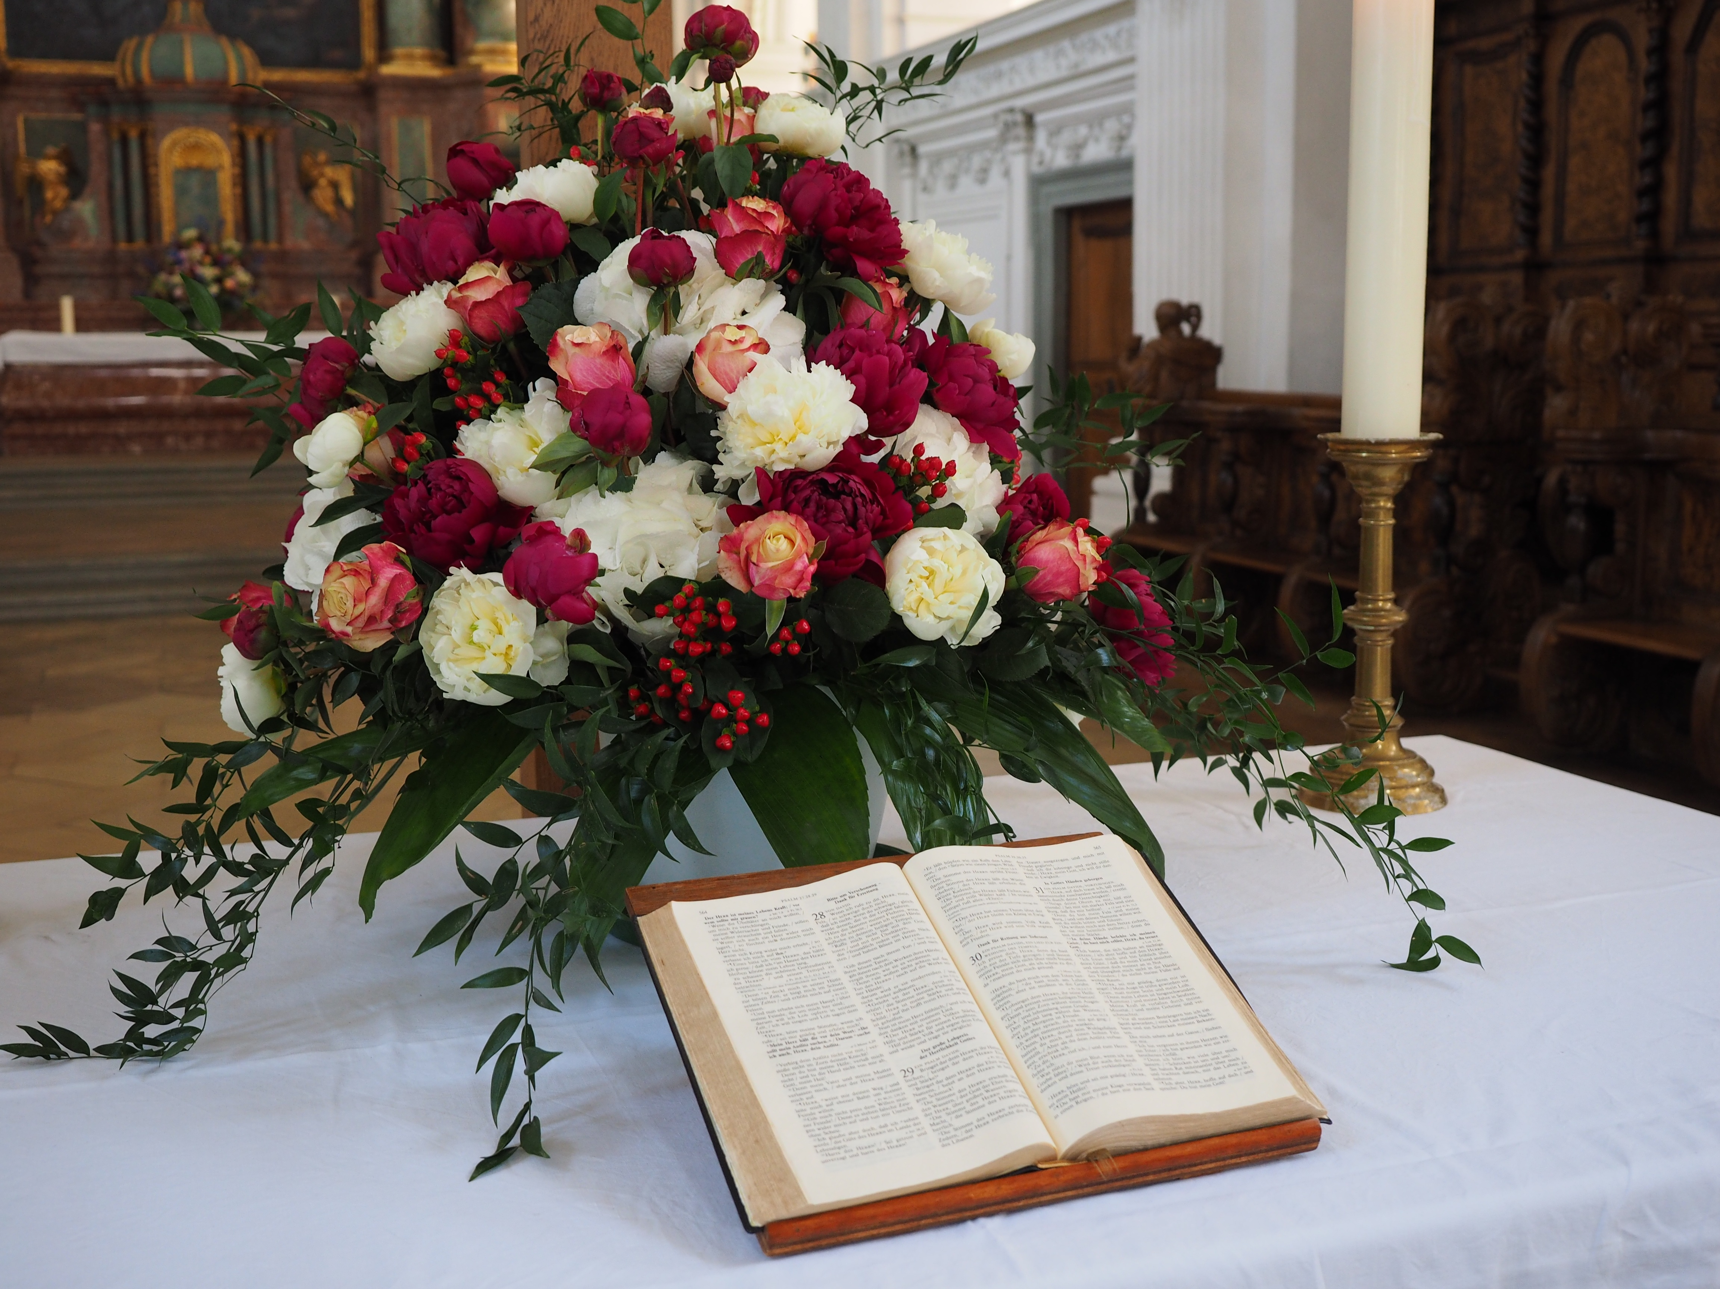
Wigston Magna News

MORE MEMORIES FROM THE 50’s

THE CINEMA -
A visit to the cinema was a regular event in the 1950’s and there were many picture houses to choose from. Queues would form around the building when the latest blockbuster was showing. The 1950’s not only had some of the best films ever made but also some of the greatest stars including John Wayne, Alan Ladd, Gary Cooper, Frank Sinatra, Burt Lancaster and Gregory Peck to name just a few. There were plenty of popular British stars too such as Alec Guinness, Richard Todd, Michael Redgrave, Peter Cushing, Christopher Lee and Jack Hawkins. It was certainly a golden age for films.

Trips to the cinema were popular and included a Pathe newsreel, cartoons and a double bill. Saturday morning children’s cinema clubs would show serials and main film like Flash Gordon, Hopalong Cassidy, The Three Stooges and Popeye.

The Second World War was still fresh in people’s minds and there were many British films made about it – Dambusters and Bridge over the River Kwai to name just two.

The 50’s also saw the start of the ‘Carry On’ films with Carry on Sergeant starring William Hartnall, Bob Monkhouse and Dora Bryan. It was a huge success and was followed by Carry on Nurse which starred Kenneth Connor, Hattie Jacques, Leslie Phillips, Joan Sims, etc.

Science fiction also played a big part in cinema viewing with films like When Worlds Collide, 20,000 Leagues Under the Sea, The War of the Worlds, Godzilla and Invasion of the Body Snatchers.

There were also lots of musicals and Alfred Hitchcock films around
Community Cinema

Military Wives

Following a group of women in England whose partners are away serving in Afghanistan. Faced with the men’s absences, they form a choir and quickly find themselves at the centre of a media sensation and global movement, Inspired by the global phenomenon of military wives choirs, the story celebrates a band of misfit women who form a choir on a military base.

Showing At

LONG STREET UNITED REFORMED CHURCH

MONDAY 8 NOVEMBER 2021

STARTING 1.30 PM

DOORS OPEN 12.45 PM

HOT / COLD DRINKS AVAILABLE

Please contact Julie on 07544981674 to book your seat

(Masks Optional BUT Preferred)

South Wigston News

RECIPE – NOVEMBER: Beef & Bean Hotpot Bake. (Serves 4)

750g stewing steak, cut into chunks
2 large onions, roughly chopped
450g carrots, roughly chopped
1 level tablespoon plain flour
300ml hot beef stock
2 teaspoons Worcestershire sauce
400g can baked beans
2 bay leaves
600g potatoes, peeled & sliced into thin rounds.

- Preheat oven to 180 C/fan 160 C/gas 4.
- Put beef, onions carrots and flour into a baking dish and toss to combine.
- Pour in the stock, add the Worcestershire sauce, baked beans and bay leaves.
- Stir together, then arrange the potato slices on top.
- Cover with foil & bake for one and a half hours,
- Discard the foil, increase oven temperature to 200 C/
fan 180 C/gas 6, and cook for a further 30 minutes.
- Add a twist of black pepper and serve.



South Wigston News

“They shall not grow old, as we that are left grow old:
Age shall not weary them, nor the years condemn.
At the going down of the sun, and in the morning
We will remember them”.
Laurence Binyon (1869 – 1943)

GARDENING NOTES – NOVEMBER
1 Sow hardy varieties of peas and broad beans outside now.
2 After removing any crops, and before any tender plants go in,
give the greenhouse a thorough clean.
3 You can still plant out, as long as there is no ground frost.
4 Prune roses for winter, but don’t cut them back too far.
5 Cover perennials with compost, or a mixture of manure and peat.
6 Weed throughout one last time.

BIRTHDAYS: NOVEMBER
15th Jasu De Gouvier
29th David Miller

THOUGHT FOR THE MONTH.
People do not decide to become extraordinary.
They decide to accomplish extraordinary things.
Sir Edmund Hillary

NOVEMBER PRAYER LIST
- On All Saints Day, give thanks for those who have gone before us
in the faith.
2 The housebound and elderly.
3 Give thanks for the beauty of Autumn.
4 All who are sick, and those who care for them.
5 All children that they may enjoy Bonfire Night safely.
6 All who represent us in the Government.
7 All those leading services in our churches today.
8 The homeless.
9 All who have lost their jobs through the pandemic.
10 Innocent people who are the victims of senseless wars.
11 The members of our armed forces wherever they are serving.
12 People who are trying to heal family rifts.
13 All nations caught up in conflict.
14 On Remembrance Sunday, we remember all those who have made
the great sacrifice; and we pray for peace throughout the world.
15 The work of the Red Cross and the St John’s Ambulance Service.
16 Give thanks for the talents God has given us.
17 Those who are terminally ill, and their families.
18 All those in training for the Ministry.
19 Animal welfare organisations.
20 Our churches holding Christmas Fairs over the next few weeks.
21 Those who regularly visit our churches as leaders and preachers.
22 The bereaved.
23 Those who need to visit Food Banks, and the volunteers who help
24 All who are lonely.
25 Those receiving treatment for depression, particularly the young.
26 Those who make our areas a better place to live.
27 Give thanks for the blessings of our lives.
28 A special prayer for Richard and Shirley as Richard leads his last
service today. We give thanks for their service to our churches
and wish them a long, happy and peaceful retirement.
29 Those of no faith who are seeking a meaning to life.
30 The people of Scotland on St Andrew’s Day.
South Wigston News

The inquisitive mind of a child.

Why are they selling poppies, Mummy?
Selling poppies in town today?
The poppies, child, are flowers of love
For the men who marched away.

But why have they chosen a poppy, Mummy?
Why not a beautiful rose?
Because, my child, men fought and died
In the fields where the poppies grow.

But why are the poppies so red, Mummy?
Why are the poppies so red?
Red is the colour of blood, my child,
The blood that our soldiers shed.

The heart of the poppy is black, Mummy.
Why does it have to be black?
Black, my child is the symbol of grief
For the men who never came back.

But why, Mummy, are you crying so?
Your tears are giving you pain.
My tears are my fears for you, my child,
For the world is forgetting again.
(Author unknown)


South Wigston News

Joshua Dyer (aged 14) was tasked at school to write a poem for Remembrance Day. An hour later (without any help) he produced this..

ONE THOUSAND MEN ARE WALKING
One thousand men are walking
Walking side by side
Singing songs from home
The spirit as their guide
they walk toward the light milord
they walk towards the sun
they smoke and laugh and smile together
no foes to outrun
these men live on forever
in the hearts of those they saved
a nation truly grateful
for the path of peace they paved
they march as friends and comrades
but they do not march for war
step closer to salvation
a tranquil steady corps
the meadows lit with golden beams
a beacon for the brave
the emerald grass untrampled
a reward for what they gave
they dream of those they left behind
and know they dream of them
forever in those poppy fields
there walks one thousand men

Joshua Dyer 2019 (aged 14)

Saffron Lane News

Preachers and Readers list for Nov-Dec 2021

 | OT |  | NT | SERV | COLL |  | Preacher
Nov 7th | 36 |  | 3 | 36 | 13 |  | E Williams | Communion
Nov 14th | 4 |  | 3 | 4 | 13 |  | L Gill | Communion
Nov 21st | 6 |  | 5 | 6 | 13 |  | R Green | Communion
Nov 28th | 8 |  | 7 | # | 14 |  | P Tiplady | Family Service
Dec 5th | 30 |  | 12 | 30 | 13 |  | E Williams | Communion
Dec 12th | 12 |  | 36 | 12 | 13 |  | G Milnes | 4pm Carol Service only
Dec 19th | 3 |  | 4 | 3 | 13 |  | R Green | Communion
Dec 24th | 30 |  | 3 | # | 13 |  | M Ferris | 11.30pm Candlelight Communion service
Dec 26th |  |  |  |  |  |  |  | No Service
3 Kath T |  | 7.Angela S |  |  |  | 12.Elizabeth R |  | # No server
4.Maureen F |  | 8. Brian S |  |  |  | 13.Darren C |  | 30 Sandra
5.Sue B |  | 10.Molly B |  |  |  | 14. Mackenzie |  | 36 Dec B
6.Pat S |  | 11.Richard B

Birthdays November
6th Sue Bloxham
13th Elizabeth Richardson
30th Darren Clay

Birthdays December
11th Terry Storton
20th Steve Bloxham

Saffron Lane News

The below prayer has been forwarded by Elizabeth Richardson. It has been a comfort to her at a time of family upset and she wants to share it with others who may also be having a difficult time.





Saffron Lane News

Coffee Morning 2nd October 2021 - For Water Aid
We had been looking forward to holding this Coffee Morning which would give us a chance to meet together with Church members, family and friends of the Church. This was to be our Charity coffee morning to raise some money for Water Aid which is our 2020-2021 charity.

So, we set out the tables so that everyone could sit and talk to friends at a distance over tea or coffee with a slice of toast, some of Elizabeth’s carrot cake or some of Sandra’s chicken vegetable soup.

Pat sat at her stall selling things to raise money, Anne looked after the books we had for sale and Eileen sat taking the money. Which that the rest of the ladies - Kath, Elizabeth and Sandra, could serve the food and drinks.

Special thanks go to a lady from our friendship group who gave us a donation of £50 towards our total or the morning of £119.00. This will be added to the money we have already raised and banked.

A big THANK YOU goes to all the people who attended and made it a good morning for Saffron Lane.



Saffron Lane News

Church Bazaar November 13th 2021 – Can you Help us
11.00am till 1.00pm
Friday night at 5.00 pm after playschool close, we want to set up the stalls in the hall if you could help then it would be a help for us.
Saturday’s opening times, if any one from the group has any time to help us, Saffron Lane would be very grateful. Could you serve behind a stall, or just give general support. There are so few of us to watch things and take the money. We usually get there about 9.30am but if you can get there for the opening times that’s great for us. Just let Sandra know if you can come and help.

New Cross
Our new cross has now been completed. It looks so smart after the old cross, which had been there since 2003 when Richard arrived until now. We will have to see how long this one lasts.

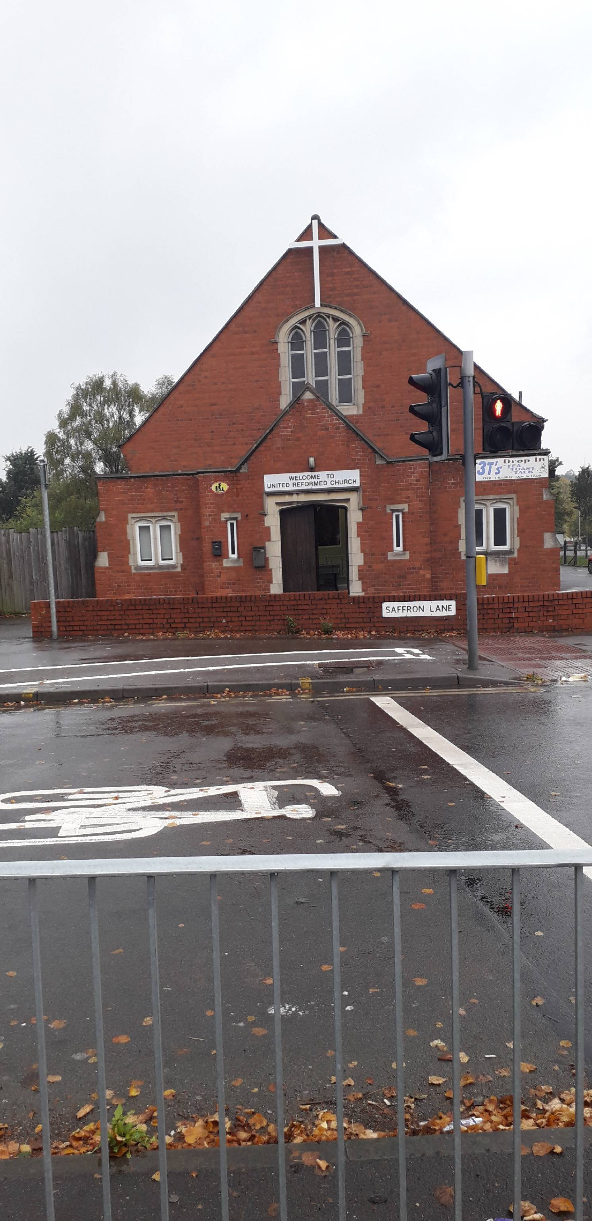

Saffron Lane News

My Shadow
by Doreen Storton

Has anyone seen my shadow?
I lost him late last night.
He vanished from my presence
As I turned out the light.

Before, he stood beside me,
Alas! Now I’m alone,
Has anyone seen my shadow?
That fiendish little gnome.

He imitates my movements,
He crawls along the ground,
He clutches onto everything,
Yet never makes a sound.

Sometimes he disobeys me,
When standing next to flame,
He dances with hysteria,
Tho’ my pose remains the same.

To get back to the question,
Please listen to my plea:
If anyone finds my shadow,
Please send him home to me

Saffron Lane News

Patterns of Life

We met and married a long time ago,
We worked long hours when wages were low,
No TV, no wireless, no bath times were hard,
Just a cold tap and a walk down the yard,
No holidays abroad, no posh carpets on the floor,
But we had coal on the fire and we didn’t lock the door.

It was quite safe to go and play in the park,
And the old folk could go for a walk in the dark,
No Valium, no drugs and no LSD,
We cured most of our ills with a nice cup of tea,
But if you were sick you were treated at once,
No fill out the form and come back in six months,
No vandals, no mugging, there was nothing to rob,
And we were quite rich on a couple of bob.
People were happy in those far days,
Kinder and caring in so many ways,

Milkmen and paper boys used to whistle and sing,
A night at the Regal or Town hall was our mad fling,
We all got our share of trouble and strife,
And we just had to face it, the pattern of life,
But now I’m older and look back through the years,
I don’t think of the bad times the trouble and tears,
I remember the blessings, our home and our love,
And that we shared them together
I thank God above.

By ANON

UNITED REFORMED CHURCH

Saffron Lane Leicester

Nr. the Pork Pie Library Roundabout

BAZAAR


BAZAAR

Christmas JOY
Saturday 13th November 2021
11.00pm – 1.00pm
Bacon Cobs, Tea, Coffee and Cakes on sale

Admission ONLY 30p

White Elephant Stall Cakes and Groceries

Christmas Cards  Raffle

Toys and Puzzles Books

Join us for our Carol Service on December 19th at 4.00pm


Also our Christmas Eve Service at 11.30pm


Whetstone News

What a busy weekend we had on 11th/12th September! Our church was open from 10am til 4pm for the "Ride and Stride" event and we also held a Coffee Morning, during which we decorated the church for Harvest.

Our Harvest Service was led by Kevin and part of the proceeds from the sale of Harvest produce was donated to Josh Laird and his family.

At the age of just 16, Josh has been diagnosed with terminal cancer. The money will allow his family to take him on holiday to create some happy memories. Please hold Josh and his family in your prayers.

Our Thursday Community Coffee Morning continues to go from strength to strength with friends old and new joining us for tea, coffee, cake, biscuits, cobs and toasties but most importantly, friendship and fellowship.



The drama group has numerous plays booked. Please support them if you can.

Whetstone News

Future Services

Preachers for November:

7th - Mrs. Shirley Eastman (Communion)
14th - Remembrance Sunday
21st - Mr. David North
28th - Rev. Richard Eastman

Christmas

We are currently planning our Candlelit Carol Service (Covid permitting) to be led by Bernard and Kevin, on Sunday 19th December at 5pm. The service will be followed by tea, coffee, mulled wine and warm mince pies. All welcome!

We will also be holding services on Christmas Day and Boxing Day, both led by Kevin.



Oadby News

Preachers for November

7th Geoff Milnes Communion

14th Revd Martin Ferris - Remembrance Sunday

21st Eileen Williams Communion

28th Revd David Howlett - Advent 1 - Toy Service

You are welcome to join us for any of these services which start
at 10.15 am

Stepping down as an active Elder

Thanks were given to Shirley Eastman for her continuing support and loyalty to our Church at Oadby. We presented her with flowers and a donation to buy a gift of her choice.

The Revd Richard Eastman incorporated this presentation during our Fifty Seventh Church Anniversary service, which we appreciated.



Oadby News

Social Activities at Oadby

Coffee & Chat Every Monday 10.00 – 12.00

Eleven O’Clock Group – 1st & 3rd Thursdays each Month
10.30 am - Coffee and Tea
11.00 am – Variety of Speakers
Lunch available afterwards

Ladies Group - Thursday 25 November 2.00 pm
Speak to Kay Brutnall or Mo Herickx for
more details

AUTUMN BAZAAR

Saturday 20 November 2021

10.00 am – 1.00 pm

Various Stalls and Games

Come Along and Join Us

News from the Former Kilby URC
MABEL STEPHENS
18 February 1922 – 29 August 2021
Now in the Presence of Her Lord

Sadly Mrs Mabel Stephens was called to her Lord at the end of August have nearly reached her 100th birthday. The Service of Celebration of Mabel’s life took place on 22 September 2021 conducted by Mrs Eileen Williams

Mabel was a member of Kilby Chapel for over 90 years. I had the privilege to have known here for over 30 years from when Gordon and I joined the chapel. Mabel was so welcoming. Whenever she chatted to you she would take your hand making you feel special as she told you of her many memories of attending chapel from the age of 2.
Mabel was one of three ladies who had kept the chapel going for many years.

At the Autumn Bazaar, Mabel was in charge of the raffle. Prior to the event she would walk the village knocking on all the doors selling raffle tickets. Harvest was another great occasion when Mabel would provide so much produce to decorate the Chapel.

Mabel played the organ for 72 years – what an achievement. She played at our wedding and also at the weddings of both my daughter and my son.

It was so good to see so many people at her funeral, a real testament of how she was respected by the village people and beyond. As we continued to celebrate Mabel’s life at the Dog & Gun in Kilby it gave us the opportunity to share together memories of Kilby Chapel and the people there some of who we only saw at the Harvest or Christmas services but with whom we all seemed to have a bond.
Well Done Mabel
Joan Seaton
An Update on the Kilby Chapel Building

Anne Emery and myself were able to gain access into the chapel as men were busy working there.

The main body of the chapel remains much the same layout but now has new windows, central heating and pure white walls. The flooring has been completely replaced.

There was a tinge of sadness as memories flooded back, thinking of the fellowship we had shared with so many over the years.

The new owners of the building are an architect’s business.

Joan Seaton

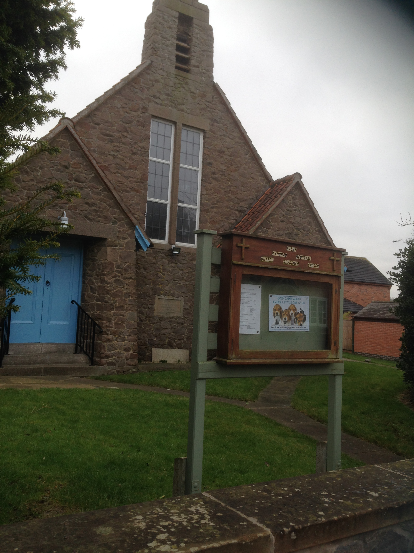
Abbots Road News

Basil and Muriel Bridge

Perhaps some of you will remember Basil Bridge being a minister at Abbots Road through the 1960’s. He over saw the closure of Bond Street Congregational Church and the subsequent building of the new church building at Abbots Road.

Basil was minister when I arrived in Leicester in 1961 to do teacher training at Scraptoft. My new friend Eileen and I were introduced to Abbots Road by two older students and were made very welcome by Basil and Muriel. Eventually Eileen returned home to Yorkshire but Dave Wren gave me a good reason to stay around.

We stayed in touch with Basil and Muriel over the years as they moved to Stamford, then Harrold before their retirement back to Norwich where they had grown up.

Sadly, Muriel died in March this year. Basil was overtaken by dementure but benefitted from having both his daughters able to take care of him. He too, died at the end of September.

It was a privilege to attend the Memorial Service held to celebrate their long lives in Sprowston, Norwich on October 8th. It was a joyful occasion, full of happy memories and singing.

The following hymn, which Basil had written, was one we sang – so suitable for the occasion.

Irene Wren

Abbots Road News

O Lord through all our days
You held us in your care,
And though we wandered from your ways,
Surprised found you there;
Wherever we have been,
Though strange the paths we trod,
There’s nothing thar could come between
Your children and their God

If such a love as this
Has followed from our birth,
Has blessed our lives, and guided us
Through all our time on earth,
Then surely you will keep
Our spirits in your care,
And bring us safely through death’s sleep
To know and find you there.

And this we dare believe
Through Jesus Christ your Son,
Who promised that he would receive
Us there, where he has gone;
He died and rose again;
And all he came to give
We know has not been given in vain;
He lives, and we shall live.

(by Basil Bridge to Diademata by George Job Elvey)

Abbots Road News

Mental Health
All my life I’ve battled with poor mental health. I have spent most of my life wearing a mask to hide the real me. That doesn’t mean I am not who you all think I am. It just gives me a layer of protection. Let me explain.
You see, I come across to the world as a very confident person but inside I am often crying out in pain. A pain that no one can see because it stays behind my mask. And I am not alone. There are so many people like me. When you suffer a painful cut or graze, it is cared for and sometimes covered, and people can see the covering making them aware that you are hurt. When the cut or graze is healed, it may leave a scar, a lasting reminder of that injury. Sometimes your wound may reopen and need more healing.

Inside my head, I carry many scars from wounds that are years old. I also have many fresh cuts which would love to be covered with savlon and a plaster, but alas, I can’t physically get to them and no one else can see them. But this doesn’t mean that they are not very real, and very painful and sometimes can be seen on the outside due to self harm and the need for someone else to see the pain.

For many years, only those closest to me knew that I suffered, but more recently, especially since my son, who also suffers, became very poorly, did I begin to change. My mask remains. My scars remain. My fresh cuts happen in waves. I can go weeks with nothing and the something triggers and ‘bang.’ Another cut.

Lately I have become very honest about mine and my families struggles. I feel so blessed because my family and some friends understand my battle and help me. Others I know would help if they could but they can’t because they don’t know.

Sunday October 10th 2021 was World Mental Health Day. I decided on that day this year to share my illness with you. And to share with you that its ‘Ok not to be Ok.’ Let’s break the stigma of poor mental health and embrace it.
Each one of us is a child of God. Unique, loved and valued. May God’s blessing fill all people with love and hope.
With love
Alison Hadley
Abbots Road News

TRAIDCRAFT IS A CHRISTIAN RESPONSE TO POVERTY.

‘Traidcraft was founded in 1979 by a group of Christians who wanted to challenge the deep injustices embedded in global trade.
We want to remain true to our origins. We do not want to stop until trade is conducted fairly for the benefit of all who participate in the supply chain.

We welcome everyone to join in our endeavour of making trade fair. We work with supporters of all faiths and none, and we work with farmers and artisans whatever their creed, ethnicity or religion. We believe that justice transcends ideology and individual beliefs’.

With my husband, David, I have been involved with Traidcraft almost from its beginning. He is now in care in Evington and I have moved to Thurnby to live with my daughter and son-in-law. I would really welcome the opportunity to continue to support Traidcraft in any way I can.

There will be a display of their lovely range of Christmas Cards in Church - it’s not always easy to find ‘real Christmas’ cards. Also the Christmas catalogue is available with a good range of food, gifts, clothing and much more. If there are items you would like to buy please let me know either in writing (give me your order in Church on Sundays) or by phoning 07397895578, giving the page number, item code, and the number required. There is no need to pay until the items arrive. If you order through me you avoid paying postage.

I really hope this is something that you will want to support - even if there is just one item you could buy regularly.

Joyce Busby

Abbots Road News

It seems we have drifted into Autumn all at once but it’s lovely to see the riot of colour as the leaves of the trees turn to gold, red and brown.

Abbots Road continues to progress thanks to Martin, Charlotte and the Elders, all working to get us back to normality. We found out that both Charlotte and Martin are accomplished musicians, Charlotte on the piano and Martin on the guitar, it came as a great surprise to us.

A generous amount of Harvest goods were gifted at our recent Harvest Service which along with £657.91 went to The Bridge, a charity who support homeless people in Leicester. The money was raised by our Saturday coffee morning folk and was added to by the church, and our Wednesday night quizzers.

Because we were locked down for nearly 18 months, during which Martin was Inducted and many folk had Birthdays and Anniversaries but were unable to celebrate, we decided to have a celebration afternoon on 30th October, a time to meet with our church family and friends.

Unfortunately, we lost one of our elderly ladies, recently, Mrs Irene Barwick. A lovely lady. Sympathy all of her family.

And now I’m looking forward to all of our winter activities.

Written by Edith Middleton.

Robert Bailey White
6 January 1940 – 22 September 2021
(Former Synod Trust & Property Officer)

It was with sadness that we heard of the death of Robert White, the former Synod Trust and Property Officer on 22 September 2021.
Robert began working for the United Reformed Church East Midlands Synod on 22 March 2004 as Trust and Property Officer, having retired as a partner at a solicitors in Nottingham. Robert’s knowledge of both Property and Trust law meant that the East Midlands Synod was able to offer the churches help with both its buildings and any property queries which arose, no matter how trivial or difficult.
Robert preferred to use hard copies of files rather than records stored on computers. As Synod increased its use of IT over the years, they would often hear Robert’s dulcet tones as he stared at the screen and called, “the document has disappeared!” or, “where will I find...?”. Robert’s approach was that you can’t take the computer to a church when you need to visit, but you can take a file.
Throughout his years with Synod nothing was too much trouble: from pitching in to help colleagues, whatever their role, to advising on matters unconnected with work, he was always ready to help.
Robert finally agreed to retire in March 2020, although even then he continued to serve as Terms of Settlement Officer.

Revd Richard Eastman made the following comment about Robert

“Robert was a great miss when he gave up the job of Synod Property Officer, but what he was, was a very safe pair of hands on the rudder, steering us (the Synod and SLG) through some difficult patches and it was always done with an air of inner confidence that gave everyone else a sense of well-being. Our loss is surely heaven's gain. I'm glad to say that I served on the Synod Enabling Group and got to know his winsome personality and his dry wit.

The Growth of a Child

If a child lives with criticism, he learns to condemn
If a child lives with hostility, he learns to fight
If a child lives with ridicule, he learns to be shy
If a child lives with shame, he learns to feel guilty
If a child lives with tolerance, he learns to be patient
If a child lives with encouragement, he learns confidence
If a child lives with praise, he learns to appreciate
If a child lives with fairness, he learns justice
If a child lives with security, he learns to have faith
If a child lives with approval, he learns to like himself
If a child lives with acceptance and friendship, he learns to find
love in this world

Dorothy Law Nolte



Prayers for the Month

During this month please pray for

Grace
Thank God for his grace.
Pray for those who feel that they
have to be perfect before God can
use them.

Encouragement
Ask God to teach you to
encourage yourself and to
talk positively to yourself

Spirit
Pray that your life will be guided
by the Holy Spirit

Trust
Pray that you will keep
Trusting God even when
there do not seem
to be any answers

Identity
Pray for those who
Compare themselves
negatively with others
and who feel under pressure
to conform.

Lectionary Readings

November 7th
1 Kings 17 8 – 16 or Ruth 3: 1-5, 4:13-17
Psalm 127 or Psalm 146
Hebrews 9 24 - 28
Mark 12: 38-64

November 14th
1 Samuel 1: 4-20. 2:1-10. Or Daniel 12 1 - 3
Psalm 16
Hebrews 10 11 – 14 (15 – 18) 19 - 25
Mark 13: 1-8

November 21st
2 Samuel 23: 1-7 or Daniel 7 9 – 10, 13 - 14
Psalm 132: 1-12, or Psalm 93
Revelation 1: 4b-8
John 18: 33-37

November 28th
Jeremiah 33: 14-16
Psalm 25: 1-10
Luke 21: 25-36

