
OCTOBER 2021
South Leicestershire Group URC

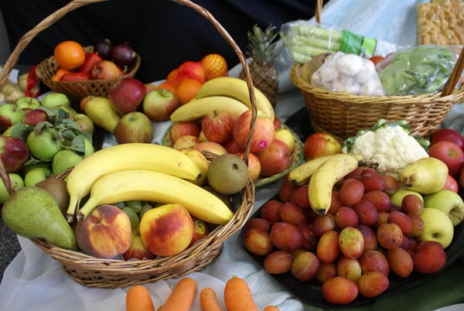

SOUTH LEICESTERSHIRE GROUP UNITED REFORMED CHURCH
Saffron Lane-Wigston Magna-South Wigston
Oadby-Whetstone
http://southleicsgroupurc.org.uk

Part of the South and East Leicestershire Area with Abbots Rd URC

Contact us:
Reverend Richard Eastman 0116 2714751
South Leicestershire Group Minister
Mrs Eileen Williams 0116 2478929
Local Church Leader
Revd Martin Ferris 0116 2419357
Resource Minister South and East Leicestershire Area

South Wigston
Di Statham Secretary 0116 2810053
Noel Oldershaw Treasurer 0116 2813398
Marion Bartholomew Magazine 0116 2717755

Wigston Magna
Eileen Williams Secretary 0116 2478929
Ray Green Acting Treasurer 0116 2887774
Ray Green Room Lettings 0116 2887774 /
07518 214144
Mary Childs Brigades Contact 07946093786
Sheila Stephens Magazine 0116 4315206
Church Office answerphone 0116 2882666

Saffron Lane
Sandra Clay Secretary/Finance/Magazine 0116 2835375
Elizabeth Richardson Treasurer 0116 2993176

Oadby
Pauline Hudson Secretary 0116 2712913
Tony Hudson Treasurer 0116 2712913

Whetstone
Janet Statham Correspondence Secretary 0116 2863335
Glenis Chapman Treasurer
Jean Warner Room Lettings 0116 2752405
Kevin West Magazine 0116 2779402

Abbots Road
Revd Pam Smith Secretary 07830037308
Eric Hanson Treasurer


Dear Friends

It is so frustrating when you make plans, that suddenly due to unforeseen circumstances they have to be scrapped or you go back to the “drawing board” as the saying goes. The pandemic has been very influential in this by turning the world upside down and scuppering plans that you may have made. The world has had to think of operating in ways that it has never done before, responding on a day to day basis. As we begin to emerge into a post pandemic world, we find ourselves having experienced many changes. There have been the conversations that say; “I can’t wait to get things back to normal”. The landscape of society and our congregations have not been inescapable from these changes, and the reality is that we will not be able to return to our pre-pandemic normal.

The world’s circumstances present itself as a wakeup call for us all. This new era we find ourselves in is an opportunity to make the necessary positive changes to move the South and East Leicestershire Area of churches forward. Let us embrace and get ready for the journey ahead together, united as one body in Christ. As I view it, the Church is entering the most amazing and exciting days that has probably not been seen in decades or maybe centuries! Although the path will not be easy, we can look ahead and expect days of great opportunity. The question for us is; where do we find the rock which shall remain unmoved by the events and circumstances that life throws at us? Paul would say; “We will no longer be infants, tossed back and forth by the waves, and blown here and there by every wind of teaching and by the cunning and craftiness of people in their deceitful scheming. Instead, speaking the truth in love, we will grow to become in every respect the mature body of him who is the head, that is, Christ” Ephesians 4: 14.

As we begin to emerge and recover, there will inevitably be changes in one form or another. Our fear of change is more to do with what we might be ask to give up for the benefit of all and how it impacts on our life. The growth and the health of the Church are becoming more difficult to maintain. If the church is to survive, the challenge for us is that we can’t continue to ‘do church’ the way we have always done it. Sudden change for any of us, as James reminds us, is the very nature of life. “Today or tomorrow we will go to this or that city, spend a year there, carry on business and make money. Why, you do not even know what will happen tomorrow” James 4: 13-14. Life is a journey with many unpredictable moments and while James warns us to be cautious and not to be influenced by the scheming motives of the world, what we ought to be saying is if it’s is the Lord’s will, we will live doing what we are being called to do in God’s name. The work which Christ completed in his glorious person as “Emmanuel, God with us”.

The SELA (South and East Leicestershire Area) review group meet soon to reflect upon some of these challenging questions. Therefore, I ask you to hold this group in prayer please; for the one thing we can be assured of is that God will never leave us and is our one constant throughout.

For I know the plans I have for you,” declares the Lord, “plans to prosper you and not to harm you, plans to give you hope and a future Jeremiah 29: 11

Shalom

Martin

SUNDAY SERVICE TIMES

Whetstone URC 10.00 am

Oadby URC 10.15 am

South Wigston URC 10.30 am

Wigston Magna 10.30 am

Saffron Lane 11.00 am

Abbots Road 10.45 am

Please check with the relevant Church Secretaries to confirm when services are taking place at any of the Group Churches.



Regular Group Church Events

MEETINGS / EVENTS ARE STARTING TO RECOMMENCE
For more information please contact the Church Secretary

South Wigston
Di Statham Secretary 0116 2810053

Wigston Magna
Eileen Williams Secretary 0116 2478929

Saffron Lane
Sandra Clay Secretary 0116 2835375

Oadby
Pauline Hudson Secretary 0116 2712913

Whetstone
Janet Statham Correspondence Secretary 0116 2863335
Jean Warner Room Lettings 0116 2752405

Abbots Road
Revd Pam Smith Secretary 07830037308

DEADLINE FOR NOVEMBER 2021 MAGAZINE

Sunday 24 October 2021

Send your items to your church representative or direct to
di.statham@btinternet.com

If you do not have a computer a hand written copy can be accepted. Contact Di Statham 0116 2810053 for information

Group AGM

Sunday 10 October

3.30 pm
at
Wigston Magna URC

Followed by Tea and Coffee
(There will Not be a Faith Tea this year)

Come and have your say on Group Matters

Wigston Magna News

SERVICES

3 MAF
10 Mr. David Todd
17 Worship Group
(this will be a Communion Service)
24 Rev. Les Gill
31 Mrs. Shirley Eastman

DIARY DATES

SUNDAY 3 “Sponsor a Child” Sunday

OCTOBER BIRTHDAYS
3 Ann Hartle
20 Elaine Wiggins
30 Les Gill
31 Jean Atkinson

FLOWER ROTA
3 Gladys Forryan Memorial
10 Barry Chamberlain
17 John Moore
24
31

If you would like to provide flowers on any occasion, or give towards the cost, please speak to Malcolm

Wigston Magna News

GROUP SERVICE

What a lovely service on Sunday September 12. It was led by members of Long Street’s Worship Group who each, in turn, read a bible passage and then elaborated on it.

The hymns were well chosen and enjoyably sung by the congregation accompanied by ‘live’ music – thank you Marian Bartholomew.

It was lovely to see representatives from our Churches as well as Abbots Road.



Wigston Magna News

UPDATE ON BABY STANLEY

As I write this he has just turned 8 weeks old. He is now making really good progress after having a very traumatic entry into the world.

He'd swallowed his meconium(poo!) which coated his lungs. This stopped him breathing which meant he was being starved of oxygen. He had to be resuscitated then blue lighted to the LRI in an ambulance from his home in Dunton Bassett. The following day he was taken to Glenfield ICU where he was given the ECMO treatment. Initially there was concern that there could be brain damage but after having an MRI scan at a later stage, they were not as concerned. He made steady progress and was allowed to go home after 3 weeks.

The care and attention given to Baby Stanley in Glenfield Hospital went above and beyond the duties of the staff. He now has a special photo album put together by the staff which recorded his daily progress. It also shows pictures of the different machines and medical instruments used on him and explanations of what they did. There are photos of Stanley. It's a lovely detailed album all about him, one to treasure for the rest of his life.

I want to say a very Big Thank you to everyone across the group churches for all the prayers given for baby Stanley. They were very much appreciated and gave us all hope in those first few weeks.
We pray that he continues to grow strong and healthy and has a happy life ahead of him.

Many thanks to you all

Julie (nanaar) Slatford
South Wigston News

RECIPE – October.
Barbecue Chicken Tray Bake (Serves 4)

8 skinless & boneless chicken thigh fillets.
2 tablespoons Schwartz Classic BBQ seasoning
2 red onions, each cut into 8 wedges
2 red & 2 yellow peppers, deseeded & cut into chunks
2 courgettes, thickly sliced
2 teaspoons cooking oil
400g cherry tomatoes on the vine.

- Preheat oven to 200 C/fan 180 C/gas 6.
- Put chicken in a large bowl, sprinkle over BBQ seasoning, toss well to coat.
- Put cooking oil into a large non-stick baking tray and spread the onions, peppers & courgettes on the tray. Season.
- Place the chicken on top, drizzle a little more oil over. Roast for 30 minutes.
- Add the tomatoes then return to the oven for a further 5 – 10 minutes.
- Divide between 4 plates and serve.

Thought for the Month Ahead.
When you have a lot of things to get done,
the best way is to do one thing at a time.
Wolfgang Amadeus Mozart.

South Wigston News

GARDENING NOTES – October
1 Aerate and scarify lawns and treat with autumn fertiliser.
2 Continue to spray roses against greenfly and fungus diseases.
3 Remove annuals and summer bedding plants before they become
bedraggled.
4 Plant spring bedding plants before severe weather sets in.
5 Give flower borders a dressing of 4oz per square yard of bone-
meal.
6 Spread a net over the pond to catch fallen leaves.



Birthdays
27 Andrew Oldershaw
31 Revd Les Gill

DIARY – October
13 Elders’ Meeting- 9.30am, followed by Church Meeting – 10.00am.

South Wigston News
PRAYER LIST – October.
Please pray for:
- Our Minister Richard, and Shirley, as they plan for retirement.
2 Farmers bringing in the last of the harvest.
3 All who preach the Word of God in our churches today.
4 Students starting a new life at university.
5 Children going through the pain of parents divorcing.
6 All those suffering from Covid or its after-effects.
7 All who work in our hospitals.
8 The Elders in our churches.
9 The people of Afghanistan who have been unable to escape.
10 All who listen to God’s Word in our churches today.
11 Refugees everywhere, especially those beginning a new life in
Britain.
12 Adults who cannot read, but who are bravely trying to learn.
13 Those with a terminal illness.
14 All who are lonely.
15 All who work to distribute Bibles.
16 Innocent people caught up in war.
17 All who read God’s Word in our churches today.
18 On St Luke’s Day, all who are sick, and those who tend them.
19 All who are unable to find work.
20 Give thanks for the beauty of Autumn.
21 All who are bereaved.
22 All those involved in educating our children and young people.
23 Give thanks for those who deliver food to our homes.
24 Blessings on all those attending our churches today.
25 Those who guard our coasts.
26 All who work for peace.
27 Those who provide entertainment for others.
28 Those who risk their lives to help others.
29 The elderly, as the nights get colder and darker.
30 Those who “go down to the sea in ships”.
31 Our friends in the other churches in our localities.
Saffron Lane News

Preachers and Readers list for Oct- Nov 2021

 | OT | NT | SERV | COLL | Preacher
Oct 3rd | 30 | 36 | 30 | 13 | E Williams | Communion
Oct 10th | 3 | 4 | 3 | !3 | M Ferris | Communion
Oct 17th | 5 | 6 | 5 | 13 | K Drinkwater | Communion
Oct 24th | 7 | 8 | # | 14 | J Slatford | Family service
Oct 31st | 12 | 30 | # | 13 | R Eastman | 5th Sunday
Nov 7th | 36 | 3 | 12 | 13 | E Williams | Communion
Nov 14th | 4 | 3 | 4 | 13 | L Gill | Communion
Nov 21st | 6 | 5 | 6 | 13 | R Green | Communion
Nov 28th | 6 | 7 | # | 14 | P Tiplady | Family Service

3 Kath T | 7.Angela S | 12.Elizabeth R | # no server
4.Maureen F | 8. Brian S | 13.Darren C | 30 Sandra
5.Sue B | 10.Molly B | 14. Mackenzie | 35 Anne
6.Pat S | 11.Richard B |  | 36 Dec B

Birthdays October
31st Les Gill

Birthdays November
6th Sue Bloxham
13th Elizabeth Richardson
30th Darren Clay

Saffron Lane News
Harvest service
On Sunday 19th September our service was led by Geoff Milnes we had a very nice service and the members and friends brought gifts for the food bank at South Wigston.

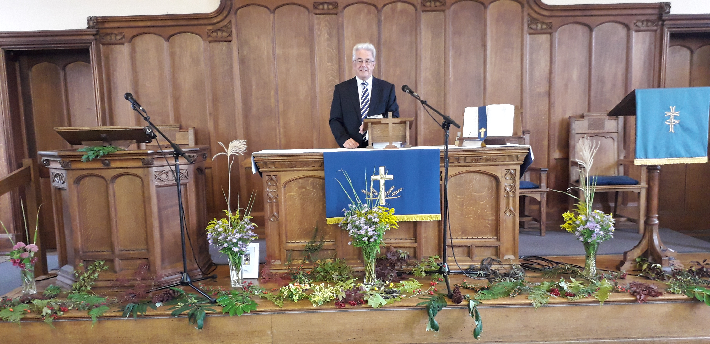

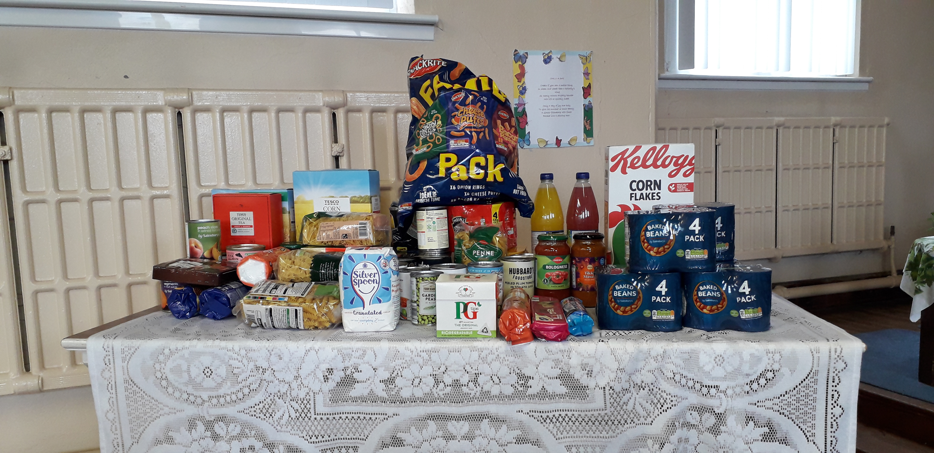

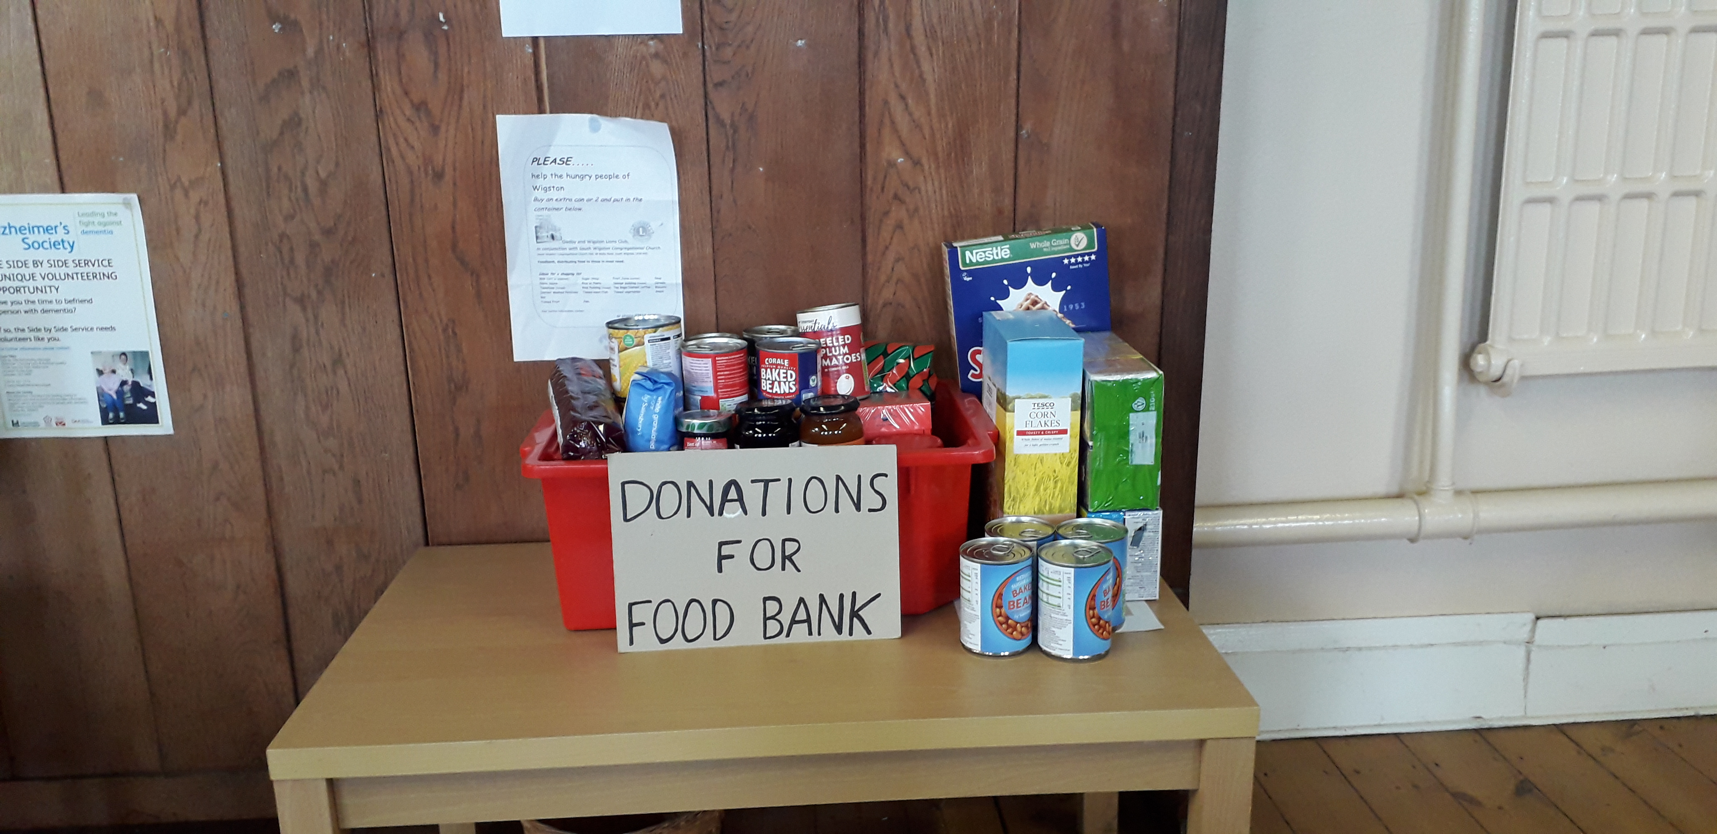
Saffron Lane News

Harvest supper
On Tuesday 22nd September we joined together with members and friends from our group of Churches to enjoy fish and chips, fellowship, and fun a time and opportunity to let our hair down. More information in the next magazine.

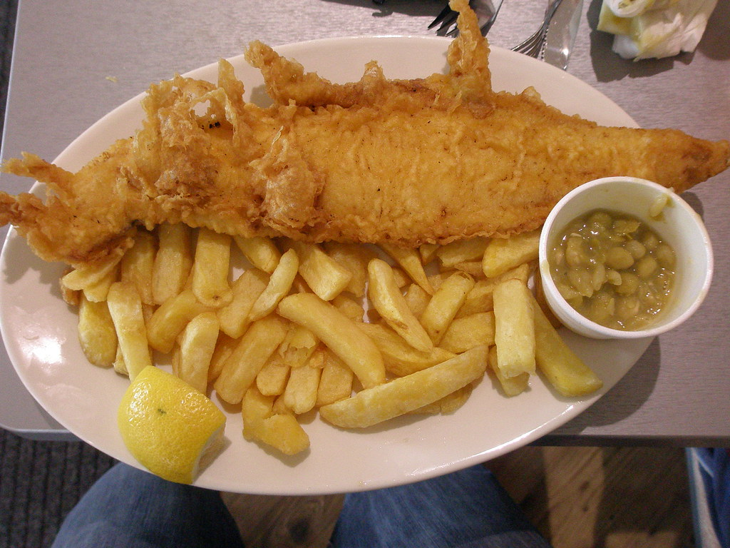

October 2nd
On Saturday 2 October we will be holding a Charity Coffee morning from 10.0-12.00 in the Church to raise money for Water Aid. Please come and support us.

Life as we knew it
After the last two years of worrying, and for some, a time of isolation, let’s forget about tiding the cupboards, throwing out all your old clothes and nick-nacks you meant to get rid of, but never had the time to do. Instead let’s be strong and move on, but by all means if you are thinking of going to a rave or night clubbing or sleeping under the stars at a weekend festival then keep safe. “Have safe fun.”

Saffron Lane News

Harvest Time by Doreen Storton

Our thanks we give to him above
Especially now at Harvest:
We thank him for the food we eat,
For gentle rain and summer heat,
For crops to flourish.

From dawn till dusk the farmers toil,
Their labours plain to see:
The land they till, the seeds they sow,
But only God can make them grow,
To give us Harvest.

Now trees have given up their fruit,
The golden fields stand bare:
Our needs by him are well supplied,
His goodness stretches far and wide,
The Lord of Harvest

And as the seasons come and go,
We view the changing scenes:
Winter’s snow, then gay Spring flowers,
Roses bloom in summer bowers,
And so to Harvest

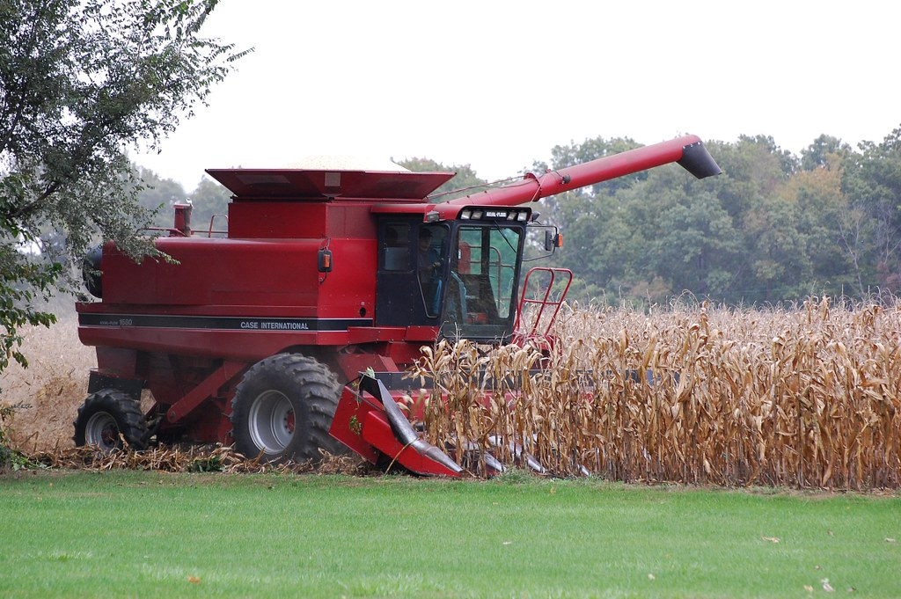
Saffron Lane News
In the beginning, God made laughter
He made it for Adam when the winter came and the leaves started to wither;
He made it for Eve when her children asked where their mum was from;
He made it for Methusaleh when the time came to blow out all the candles on his birthday cake;
He made it for Mrs. Noah when her husband first mentioned his amphibious zoo;
He made it for Abraham when a year off a hundred he was asked to walk the world;
He made it for Sarah when she eavesdropped on an angel and giggled until she was pregnant;
He made it for Moses when the sheep raised their heads in confusion at his stutter;
He made it for Miriam when she danced on dry land as a sign of liberation;
He made it for wee David when Saul offered to make him the youngest lance corporal;
He made it for big Goliath, when he first glimpsed the cause of impending rigor mortis;
God made laughter for himself when his children on Earth took themselves too seriously;
And - he gave it to Jesus to share with his friends,
to use in his stories,
to praise in young children,
to bring to the sad.
So, we dare not in our wisdom, doubt that God inhibits humour,
Nor condemn him to be dour like some bankrupt undertaker.
From his spirit issues joy, and that fruit is for our healing.

Taken from a book called Flowing Streams.
“In the beginning” (Source unknown)
Provided by Elizabeth Richardson

Saffron Lane URC
(Pork Pie Island)

Coffee Morning

Saturday 2 October 2021

10.00 –12.00


Oadby News

Preachers for October
3rd Shirley Eastman - Communion

10th Eileen Williams

17th Revd Jacquie Gavin - Communion

24th Revd Richard Eastman

31st Revd David Howlett

Please feel free to come along and join us. Our services start at 10.15 am each Sunday.


Abbots Road News

ABBOTS ROAD, DATES FOR YOUR DIARY

Sunday 3rd. October - Harvest Service
led by Reverend Martin Ferris

Sunday 31st October - Church Meeting,
which will take place after worship.

A FREEDOM PRAYER

Dear God,
We thank you that after many months of restrictions, we have entered a new phase of ‘freedom’ with fewer restrictions. But we still need to be careful and responsible, to not only protect ourselves, our family, our church family but also our neighbours. May we be a responsible, loving and caring people, for in this way, we not only exercise our freedom, but also our faith.
Amen

DARK TIMES, OPPORTUNITES FOR GROWTH.
Most people go through times of emotional or spiritual darkness. When it happens, accept that life can be like that, it’s not all sunshine and roses but don’t consent to stay in the darkness. Go slowly, taking care, like you would in any dark place. Give God your cares. God is with you and more often than not he will prompt someone to offer an outstretched hand, take it as a gift from God. We all need support in the dark times. And remember that darkness is nothing more than the preparation for growth for every seed that grows in the ground. Ready. Get set. Grow.

Abbots Road News

RECIPE FOR SWEET ONION JAM

25g (1oz) butter
680g (11/2lb) onions, peeled and thinly sliced
150g (5oz) caster sugar
1 tsp salt
1 tsp freshly ground black pepper
100ml (31/2 fl oz) sherry vinegar or balsamic vinegar
250ml (9 fl oz) full - bodied red wine
2 tbsp crème de cassis

Method
- Melt the butter in a saucepan and add the onions, sugar, salt and
freshly ground black pepper.
- Stir, then cover the saucepan and cook for 30 minutes over a
gentle heat, stirring from time to time to prevent it from
sticking to the bottom of the pan.
- Remove the lid and add the vinegar, wine and crème de cassis.
- Cook, uncovered, for another 30 minutes, stirring every now and
then. It should be slightly thick by now.
- Pour into sterilised jars and cover while hot.
It thickens as it cools.

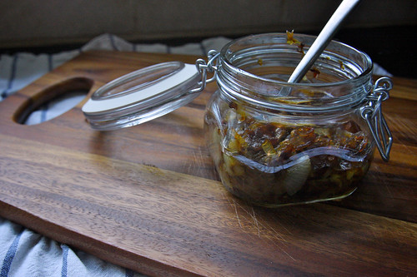

A Couple of Jokes contributed by June White (Abbots Rd)

A woman was in the bathroom, putting on her makeup, under the watchful eyes of her young granddaughter, as she’d done many times before. After she applied her lipstick and started to leave, her little granddaughter said, ‘But grandma you forgot to kiss the toilet paper goodbye.’ I will probably never put on lipstick on again without thinking about kissing the toilet paper goodbye!

A six year old was asked where her grandmother lived. “Oh”, he said, “she lives at the airport, and when we want her, we just go to get her. Then, when we’re done having her visit, we take her back to the airport.

And One from Revd Richard Eastman

A little boy wanted £100 badly and prayed for one week but nothing happened. Then he decided to write God a letter requesting £100.
When the postal authorities received the letter addressed to GOD UK, they decided to send it to the Prime Minister.

The Prime Minister was so impressed, touched, and amused that he instructed his secretary to send the little boy a £5 note. The Prime Minister thought this would appear to be a lot of money to a little boy. The boy was delighted with the £5 and sat down to write a
thank you note to God, which read:

Dear God,
Thank you very much for sending the money. However, I noticed that for some reason you had to send it through Downing Street
and, as usual, they took most of it.

Lectionary Readings

October 3rd 2021
Genesis 2: 18-24
Psalm 8
Hebrews 1: 1-4, 2:5-12
Mark 10: 2-16

October 10th 2021
Amos 5: 6–7, 10–15
Psalm 90: 12-17
Hebrews 4: 12-16)
Mark 10:17-31

October 17th
Isaiah 53: 4-12
Psalm 91: 9-16
Hebrews 5: 1-10
Mark 10: 35-45

October 24th
Jeremiah 31: 7-9
Psalm 126
Hebrews 7: 23-28
Mark 10: 46-52

October 31st
Deuteronomy 6: 1-9
Psalm 119: 1-8
Hebrews 9: 11-14
Mark 12: 28-34

